$ echo 6 + 3
This will print 6 + 3, not the sum 9, To do sum or math operations in shell use expr, syntax is as
follows Syntax: expr op1 operator op2
Where, op1 and op2 are any Integer Number (Number without decimal point) and operator can be
+ Addition
- Subtraction
/ Division
% Modular, to find remainder For e.g. 20 / 3 = 6 , to find remainder 20 % 3 = 2, (Remember its
integer calculation)
\* Multiplication

$ expr 6 + 3
Now It will print sum as 9 , But

$ expr 6+3
will not work because space is required between number and operator

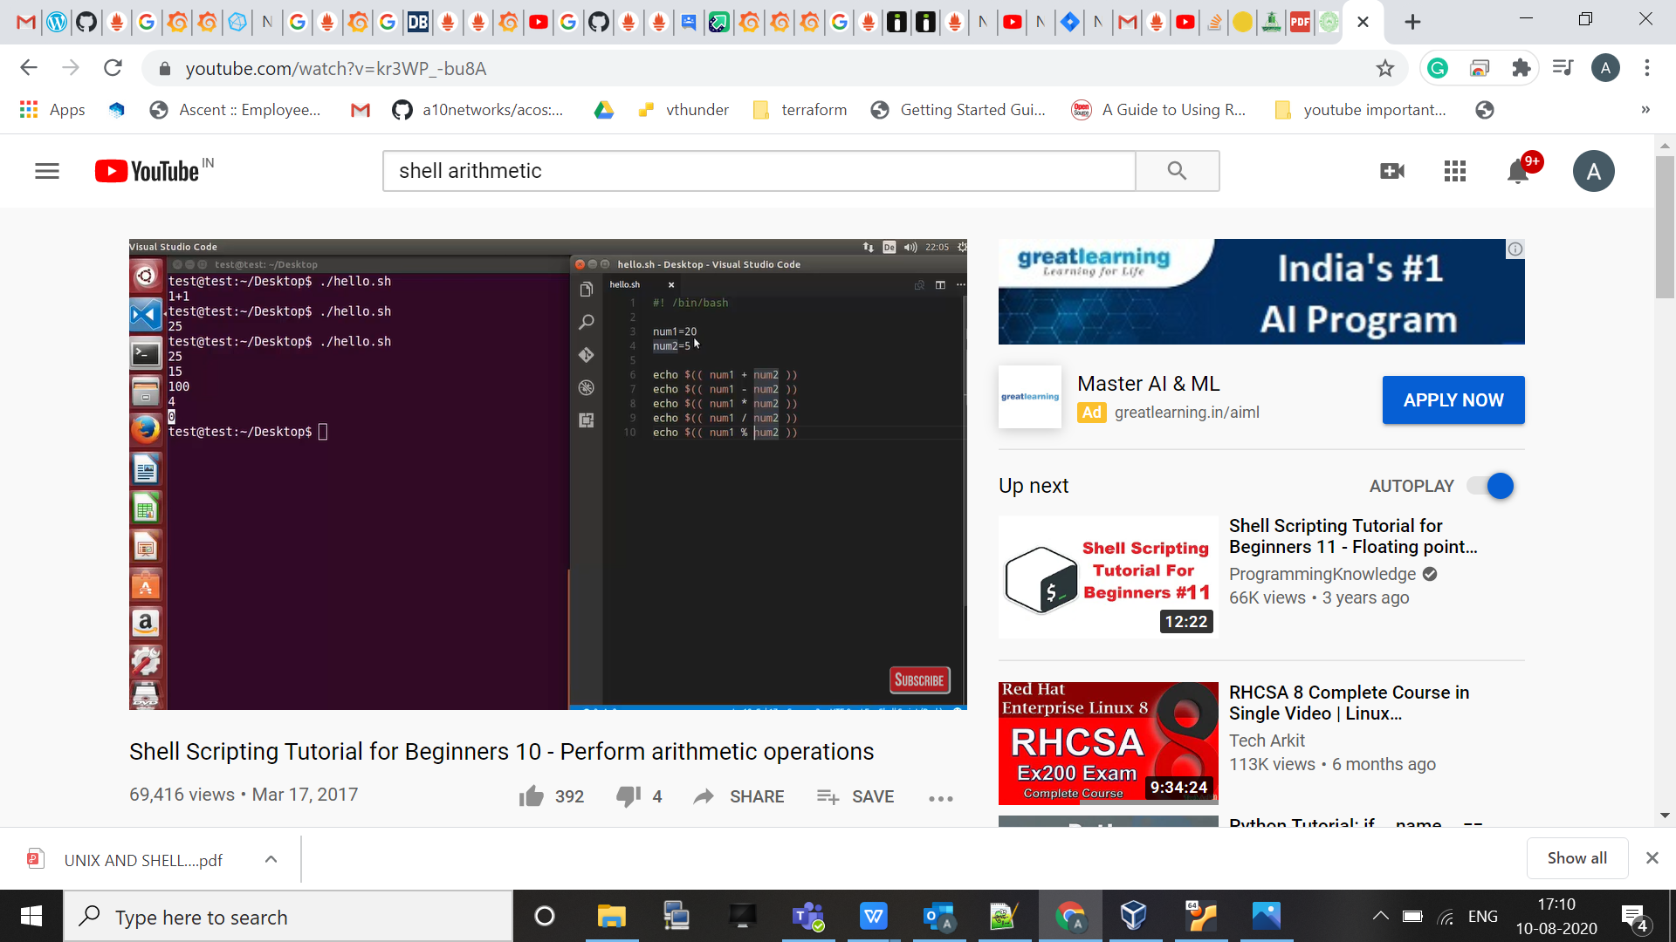

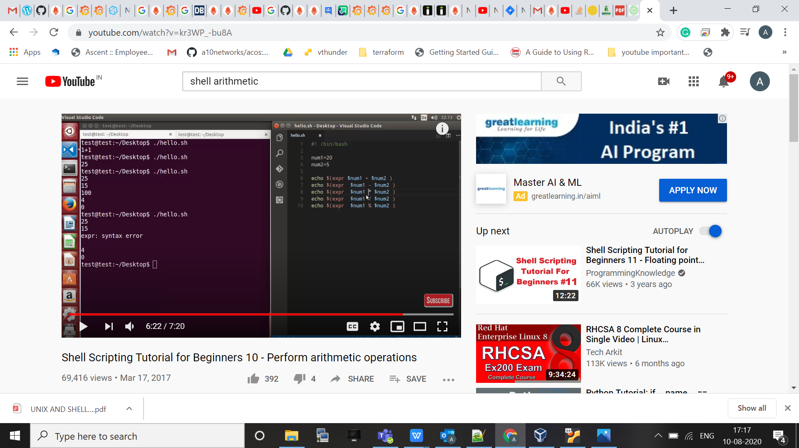

Now here we use single bracket , for that to happen we use “expr” keyword and other variable is used as normal variable “$var”.

One thing to observe , this “syntax error” , so we have to use forward “\*” like

